Analysis of restaurants in Toronto,Ontario.

# A detailed analysis for setting-up a new restaurant.

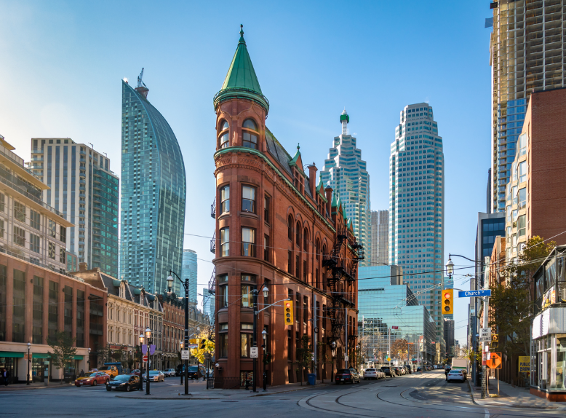

# Kevin Pant

## Overview of the city of Toronto.

# Toronto is the [provincial](https://en.wikipedia.org/wiki/Provinces_and_territories_of_Canada) [capital](https://en.wikipedia.org/wiki/Capital_city) of [Ontario](https://en.wikipedia.org/wiki/Ontario) and the [most populous city](https://en.wikipedia.org/wiki/List_of_the_100_largest_municipalities_in_Canada_by_population) in [Canada](https://en.wikipedia.org/wiki/Canada), with a population of 2,731,571 in 2016. Current to 2016, the Toronto [census metropolitan area](https://en.wikipedia.org/wiki/Census_metropolitan_area) (CMA), of which the majority is within the [Greater Toronto Area](https://en.wikipedia.org/wiki/Greater_Toronto_Area) (GTA), held a population of 5,928,040, making it Canada's [most populous CMA](https://en.wikipedia.org/wiki/List_of_census_metropolitan_areas_and_agglomerations_in_Canada). Toronto is the anchor of an urban agglomeration, known as the [Golden Horseshoe](https://en.wikipedia.org/wiki/Golden_Horseshoe) in [Southern Ontario](https://en.wikipedia.org/wiki/Southern_Ontario), located on the northwestern shore of [Lake Ontario](https://en.wikipedia.org/wiki/Lake_Ontario). A [global city](https://en.wikipedia.org/wiki/Global_city), Toronto is a centre of business, finance, arts, and culture, and is recognized as one of the most [multicultural](https://en.wikipedia.org/wiki/Multicultural) and [cosmopolitan](https://en.wikipedia.org/wiki/Cosmopolitanism) cities in the world. [People](https://en.wikipedia.org/wiki/Indigenous_peoples_in_Canada) have travelled through and inhabited the Toronto area, situated on a broad sloping [plateau](https://en.wikipedia.org/wiki/Plateau) interspersed with [rivers, deep ravines, and urban forest](https://en.wikipedia.org/wiki/Toronto_ravine_system), for more than 10,000 years.

# Introduction and Business Problem

A client wants to open a restaurant in the city on Torento, Ontario and has approached me to narrow down a locality in which he needs to set up his Business.Toronto covers an area of 630 square kilometres, with a maximum north–south distance of 21 kilometres and a maximum east–west distance of 43 km and is the fourth-most-populous North American city by population (2,826,498) which makes it a good location to set up Business.

The province of Ontario has 24 publicly funded colleges and the city of Toronto has 451 elementary schools, 110 secondary schools, and 5 adult education schools educating over 289,577 students, additionally Toronto has a total of 103 neighbourhoods and my client wants to know what would be the most lucrative spot to set up shop.

For a restaurant to flourish there are certain prerequisites that need to be fulfilled and the most important prerequisite is that of choosing the right location to set up shop and this precisely why my client has approached me. So our main *Business Problem* is that of choosing the right location. Now, for us to choose the right location we will be needing information about various neighbourhoods of Toronto. Choosing the right location implies setting up shop where "Competition" is relatively less and footfall is relatively more. In other words we got to find a location where population density is more and our immediate competitors are less.

So our focus should be setting up shop in an area which has the following attributes :

* Locality where there are relatively less number of Restaurants.
* Locality close to Colleges, Schools and Work Places(Offices) as our main footfall will come from Students and Office personnel.

In order to maximize profitability you have got to find the right 'Spot' and my project does exactly the same.

82

# Dataset.

In this section I will be introducing the various Data sets being used that will help determine the perfect location for my client to set up his Business.

The Localities of Toronto, Ontario from the Wikipedia

page: <https://en.wikipedia.org/wiki/List_of_postal_codes_of_Canada:_M>.

* From the provided wikipedia page I will extract relevant infornmation, particularly information regarding various Neighbourhoods, Boroughs and Postal Codes of the city of Toronto.

The geographical coordinates of each postal code: <http://cocl.us/Geospatial_data>

* Data regarding the coordinates i.e. (latitude & longitude) to the above Neighbourhoods of Toronto will be extracted from the above link.

I will be using Foursquare for the most important part of the project, that is collecting data regarding the location. (Location Data)

Foresquare will help me find the following:

* Restaurants of nearby neighborhoods.
* Office spaces of nearby neighborhoods.
* Schools of nearby neighborhoods.
* Colleges of nearby neighborhoods’.

Once we have all our data with us with the help of the Pandas library I will create a neat little Data Frame.

Leveraging the Data Frame at hand I will determine which neighborhood will be the most appropriate for my client to set up his restaurant.

**Methodology**

For each neighborhood all the offices, schools, colleges and restaurants data have been collected from Foursquare.

Given these neighborhoods, I have calculated the sum of office, school, colleges and restaurants.

Now that we have four categories namely “Schools”, “Restaurants”, “Colleges”, and “Offices” a weight (penalty) has been assigned to each one of them.

Restaurants have been assigned a weight of (-1), as I want to avoid locating my clients restaurant close to any other restaurant.

Schools have been assigned a weight of (+1), as I consider students an average customers.

Universities have been assigned a weight of (+1.5), because lets’ face it, college students are perpetually hungry.

Offices have been assigned a weight of (+2), because I consider office employees my best customers.

Given the weights assigned to each category, a score was computed for each neighborhood as the weighted sum of the number of venues in each of the four categories.

**Neighborhoods of Toronto, Ontario.**

From the Wikipedia page I web-scrapped the relevant part, mainly the “Postal Code”, “Borough”, “Neighborhood”, “Latitude” and “Longitude” and using Pandas converted into a neat table.

This table consists of all the neighborhoods in Toronto, Ontario.

To make it visually appealing I have added a map of the neighborhoods of Toronto using the Folium library in python.

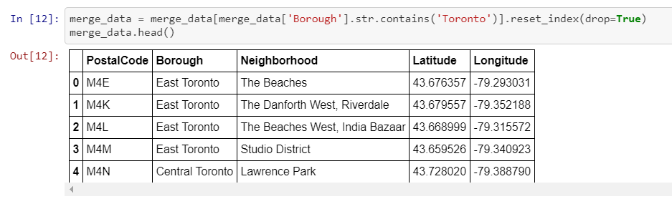

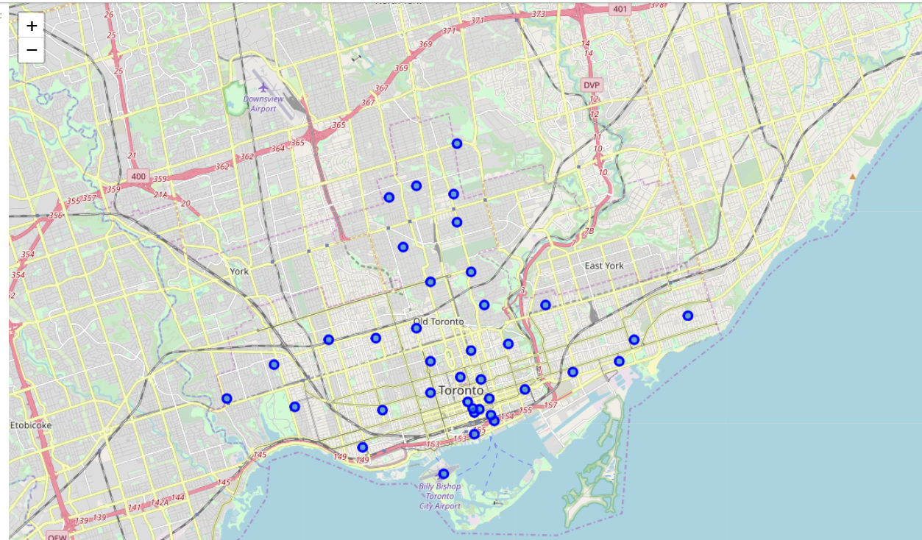

**Restaurants in Toronto, Ontario.**

Using Foresquare I was able to extract all the restaurants in the neighborhood of Toronto, Ontario. For a quick summary I have provided a snapshot of the first five restaurants in Toronto’s neighborhoods.

I moved the relevant part of information from the table, mainly the location of each restaurant to a map, just to get a clear picture of where the majority of restaurants were located in Toronto.

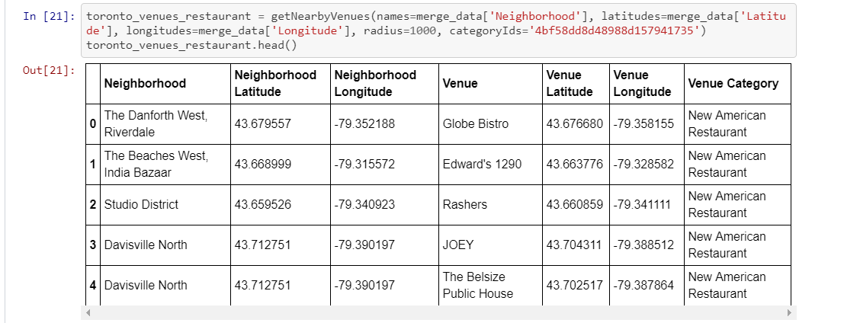

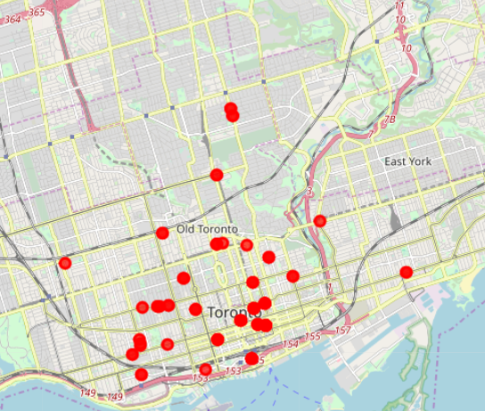

**High Schools in Toronto, Ontario.**

Using Foresquare I was able to extract all the high schools in the neighborhood of Toronto, Ontario. For a quick summary I have provided a snapshot of the first five high schools in Toronto’s neighborhoods.

I moved the relevant part of information from the table, mainly the location of each high school to a map, just to get a clear picture of where the majority of high schools were located in Toronto.

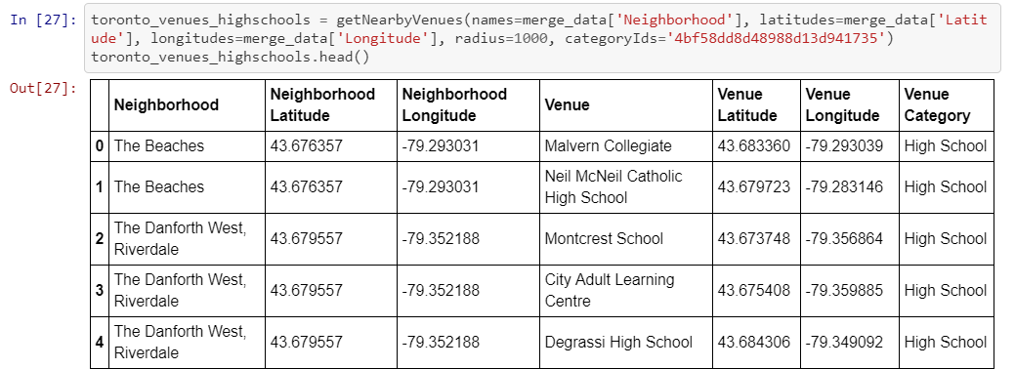

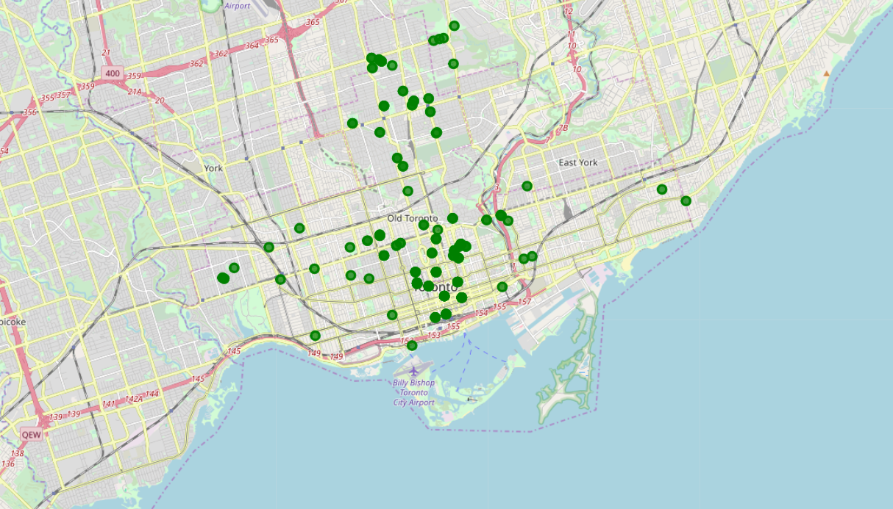

**Colleges in Toronto, Ontario.**

Using Foresquare I was able to extract all the colleges in the neighborhood of Toronto, Ontario. For a quick summary I have provided a snapshot of the first five colleges in Toronto’s neighborhoods.

I moved the relevant part of information from the table, mainly the location of each college to a map, just to get a clear picture of where the majority of colleges were located in Toronto.

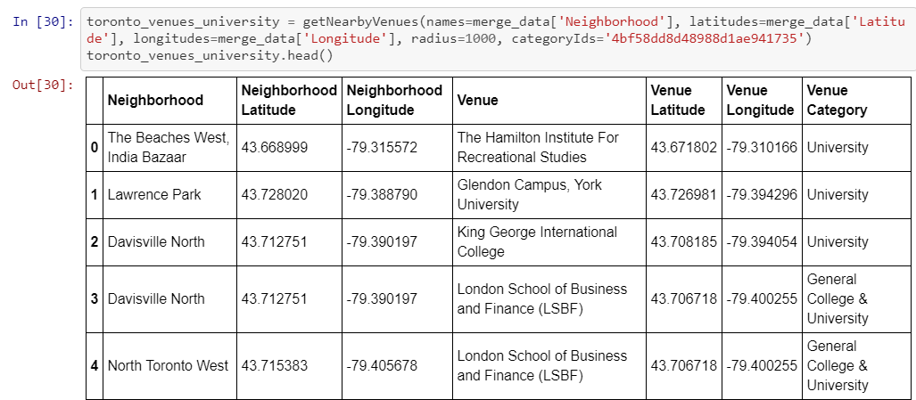

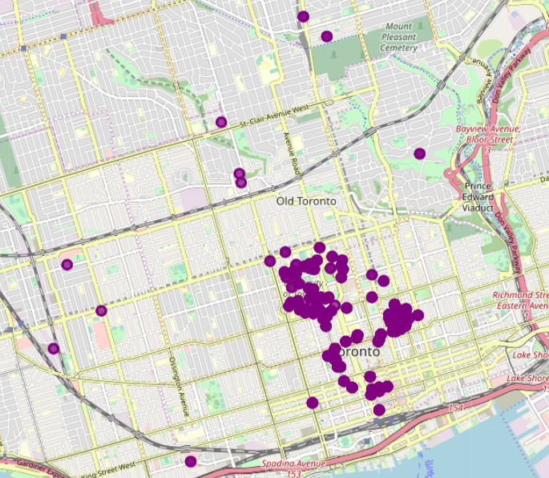

**Offices in Toronto, Ontario.**

Using Foresquare I was able to extract all the offices in the neighborhood of Toronto, Ontario. For a quick summary I have provided a snapshot of the first five offices in Toronto’s neighborhoods.

I moved the relevant part of information from the table, mainly the location of each college to a map, just to get a clear picture of where the majority of offices were located in Toronto.

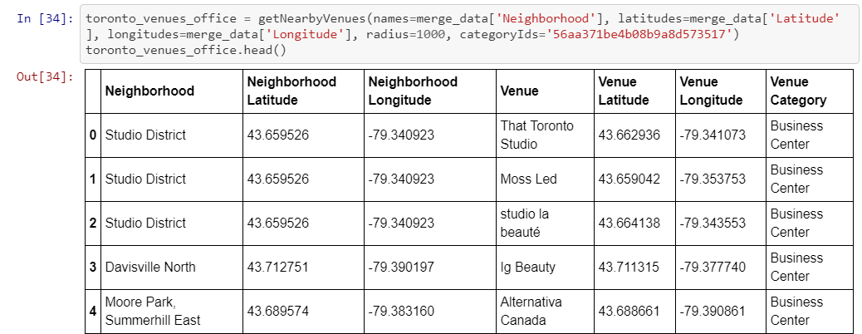

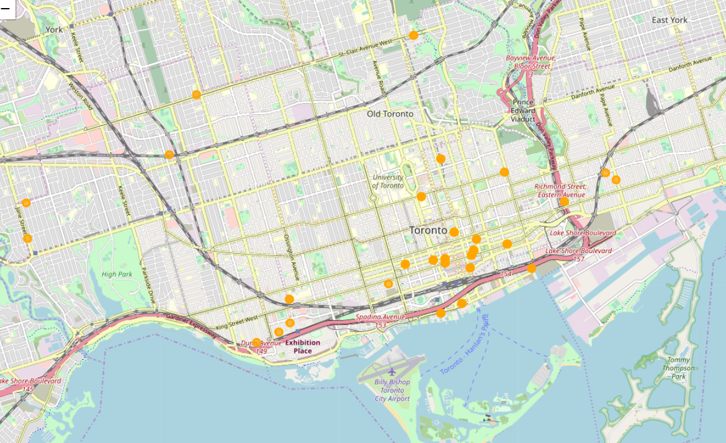

**RESULTS.**

After our analysis we come to a conclusion that the neighborhood of “Central Bay Street” is the best location to set up a restaurant business as it is close in proximity to schools, colleges, universities and offices and with the highest score of 97.5.

Setting up a restaurant in this neighborhood will surely maximize the number of customers rather than setting up a restaurant in some other neighborhood.

“Bay Street” was originally known as Bear Street because of frequent bear sightings in the early history of Toronto. It was renamed Bay Street in 1797 from the fact that it connected Lot Street (present-day [Queen Street West](https://en.wikipedia.org/wiki/Queen_Street_West)) to a bay at the [Toronto Harbour](https://en.wikipedia.org/wiki/Toronto_Harbour).

Bay Street is a major thoroughfare in Downtown Toronto, Ontario, Canada. It is frequently used as a metonym to refer to Toronto's Financial District and the Canadian financial sector as a whole, similar to [Wall Street](https://en.wikipedia.org/wiki/Wall_Street) in the United States.

I have provided a snapshot of the top score of neighborhoods to set up a restaurant.

Along with the snapshot of the best score I have provided a map that shows us the best location to set up our restaurant.

In the map, the “Blue marker” is the neighborhood that is most suitable to set up my clients restaurant.

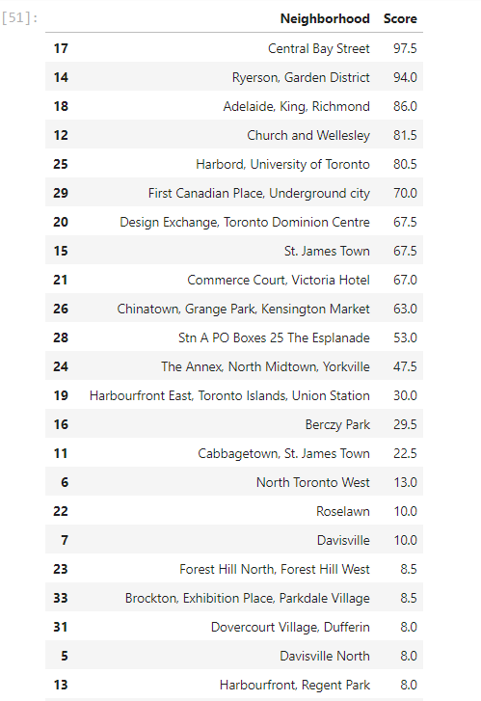

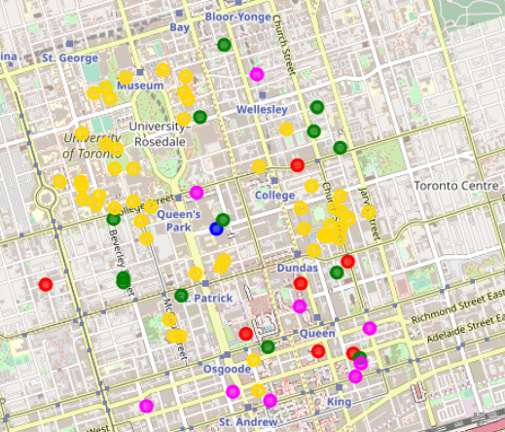

**CONCLUSION.**

In this project I aimed to analyze the best spot to open a restaurant in Toronto, Ontario. For this I considered various datasets that were all available online. Using weighted means approach I came to a conclusion that “Central Bay Street” is best the neighborhood to set up a restaurant as it would receive maximum number of footfall.